TASK 1:
#include<iostream>

using namespace std;

class simple
{
private:
int x;
int y;
int z;
public:
simple()
{
x = 2;
y = 3;
z = 4;
}

void simplefunction();
};
void simple::simplefunction()
{
cout <<"x is equal to" <<x<<endl;
cout << "y is equal to" << y << endl;
cout << "z is equal to" << z << endl;
}

int main()
{
simple c1;

c1.simplefunction();

system("pause");
}
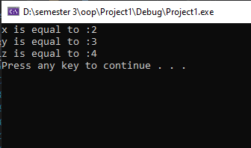
TASK 2:
#include<iostream>

using namespace std;

class simple
{
private:
int x;
int y;
int sum;

public:
simple(int x1, int y1)
{
x = x1;
y = y1;

}
void input_fun();
void add();
};
void simple::input_fun()
{

cout << "Enter the value of x :";
cin >> x;
cout << "Enter the value of y :";
cin >> y;
}
void simple::add()
{
sum = x + y;
cout <<"Sum is equal to :" <<sum<<endl;
}

int main()
{
int x=0, y=0;

simple c3(x,y);
c3.input_fun();
c3.add();
simple c2(x, y);
c2.input_fun();
c2.add();
system("pause");
}
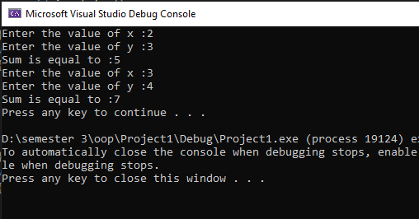

TASK 3:

#include<iostream>
#include<string>

using namespace std;
class student
{
string name;
int rollnumber;
int CGPA;
int CNIC;
public:
student()
{
name = " ";
rollnumber = 0;
CGPA = 0;
CNIC = 0;
}
void input()
{
cout << "Enter name of student ";
cin >> name;
cout << "Enter rollnumber of student ";
cin >> rollnumber;
cout << "Enter CGPA of student ";
cin >> CGPA;
cout << "Enter CNIC of student ";
cin >> CNIC;

}
void display()
{
cout << "The name of the student is " << name;
cout << "The rollnumber of the student is " << rollnumber;
cout << "The CGPA of the student is " << CGPA;
cout << "The CNIC of the student is " << CNIC;
}
};
int main()
{
int size;
cout << "Enter the number of students ";
cin >> size;
student *stu1 = new student[size];

for (int i = 0; i < size; i++)
{
stu1[i].input();
}
for (int i = 0; i < size; i++)
{
stu1[i].display();
}
system("pause");
}
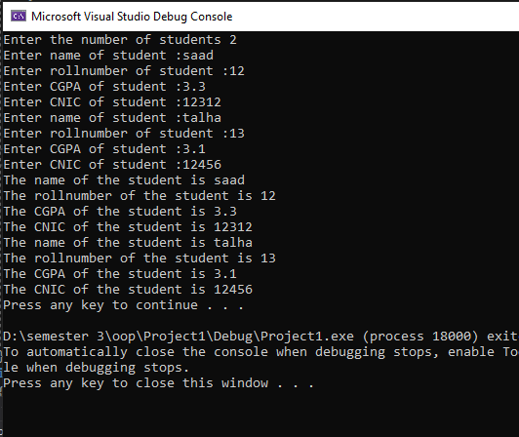

TASK 4:
#include<iostream>
#include<string>

using namespace std;
class student
{
string name;
int age;
float GPA;

public:
student()
{
name = "XYZ";
age = 18;
GPA = 3;

}
void input()
{
cout << "Enter name of student ";
cin >> name;
cout << "Enter age of student ";
cin >> age;
cout << "Enter GPA of student ";
cin >> GPA;

}
void display()
{
cout << "The name of the student is " << name<<endl;
cout << "The rollnumber of the student is " << age << endl;
cout << "The CGPA of the student is " << GPA << endl;
}
};
int main()
{
int size=5;

student* stu1 = new student[size];

for (int i = 0; i < size; i++)
{
cout << "Enter the details of student " << i + 1<<endl;
stu1[i].input();
}
for (int i = 0; i < size; i++)
{
cout << "The details of student " << i + 1 << endl;
stu1[i].display();
}
system("pause");
}

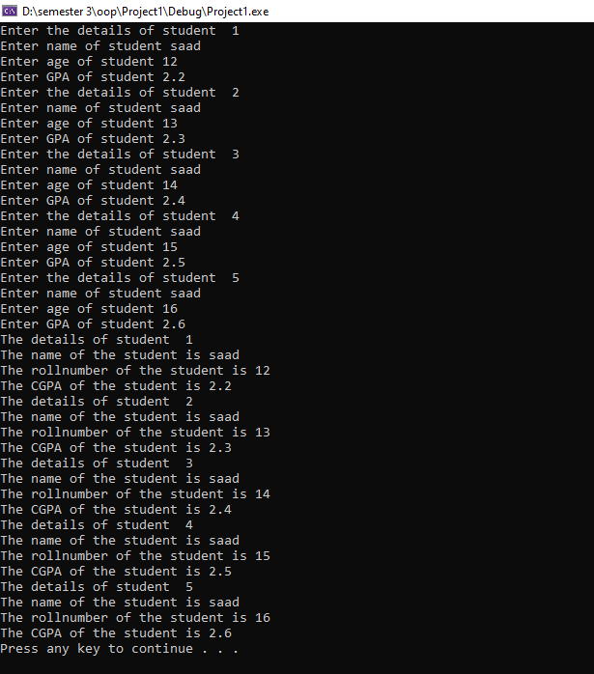
TASK 5:
#include<iostream>

using namespace std;

class addition
{
int* ptr;
int nums;
public:
addition()
{
cout << "Enter numbers to add : ";
cin >> nums;
ptr = new int[nums];
for (int i = 0; i < nums; i++)
{
cout << i + 1 << " . ";
cin >> ptr[i];
}
}

void add()
{
int added = 0;
for (int i = 0; i < nums; i++)
{
added = added + ptr[i];
}
cout << "After addition = " << added << endl;
}

};
int main()
{
addition obj;
obj.add();
system("pause");
}
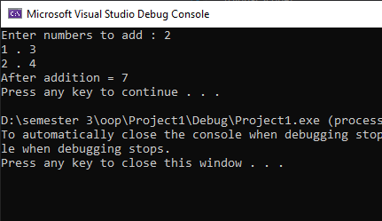
TASK 6:
#include<iostream>
#include<string>

using namespace std;
class time
{
int hour;
int minutes;
int seconds;

public:
time()
{
hour = 0;
minutes = 0;
seconds = 0;
}
void input()
{
cout << "Enter number of seconds ";
cin >> seconds;

}
void display()
{
cout << "Hours : Minutues : Seconds"<<endl;
minutes = seconds / 60;
hour = minutes / 60;
cout << (hour) << "\t" << minutes % 60
<< "\t" << seconds % 60 << endl;
}
};
int main()
{
time t1;
t1.input();
t1.display();

system("pause");
}

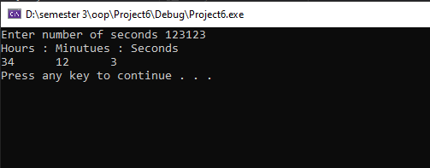

TASK 7:
#include<iostream>
#include<string>

using namespace std;
class time
{
int hour;
int minutes;
int seconds;

public:
time()
{
hour = 0;
minutes = 0;
seconds = 0;
}
void input()
{
cout << "Enter number of hours ";
cin >> hour;
cout << "Enter number of minutes ";
cin >> minutes;
cout << "Enter number of seconds ";
cin >> seconds;

}
void display()
{
int a = hour * 3600;
int b=minutes * 60;
int result = a + b + seconds;

cout << "The seconds in the above time is " << result<<endl;
}
};
int main()
{
time t1;
t1.input();
t1.display();

system("pause");
}

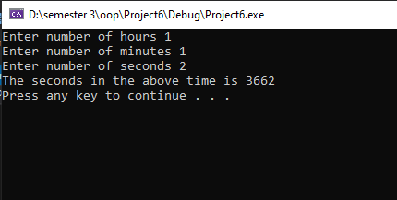

TASK 9:
#include<iostream>

using namespace std;

class class1
{
public:
class1()
{

}
void display()
{
cout << "Hey! this is class 1"<<endl;
}

};
class class2
{
class1 c2;
public:
class2()
{

}
void display()
{
class1 obj;
obj.display();
cout << "Hey! this is class 2" << endl;
}

};
int main()
{

class2 obj;
obj.display();
system("pause");
}

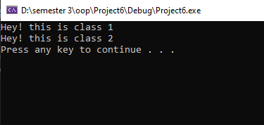

TASK 10;
#include<iostream>

using namespace std;

class votes
{
public:
string nameofcandidates;
int voterecieved;
votes()
{
nameofcandidates = " ";
voterecieved = 0;

}
void inputnameofcandidate()
{
cout << "Enter the name of candidates :";
cin >> nameofcandidates;
}
void inputvote()
{
cout << "Enter the number of voter recieved :";
cin >> voterecieved;
}
void display()
{
cout << nameofcandidates;
cout << "\t";
cout << voterecieved;
cout << "\t";
}

};
int main()
{

int size = 5;
float sum = 0;
votes* p = new votes[size];
float result ;

for (int i = 0; i < 5; i++)
{
p[i].inputnameofcandidate();

p[i].inputvote();

}

cout << "name of candidates" << " " << "vote " << "percentage" << endl;
for (int i = 0; i < 5; i++)
{
sum += p[i].voterecieved;
}
for (int i = 0; i < 5; i++)
{
p[i].display();
result = (p[i].voterecieved / sum)*100;

cout << result <<"%"<< endl;

if (p[i].voterecieved < p[i+1].voterecieved)
{
p[0].nameofcandidates =p[i].nameofcandidates;
}

}
cout <<"The Winner is :" <<p[0].nameofcandidates<<endl;

system("pause");
}
